Little Yellow Duck by Suzy Compton May 2014

Use double knit yarn and 3¼ mm needles. Work in stocking stitch throughout. Leave enough yarn at the beginning of casting on and at the end of casting off to sew the duck together. You can easily adapt this pattern to make fatter or thinner ducks, just add in or take out shaping rows when necessary. You can also make a stripy duck, working 2 or 4 rows in each colour and carrying the unused yarn up the side of the work.
A teeny tiny duck can be made by using 4 ply yarn and 2¾ mm needles.

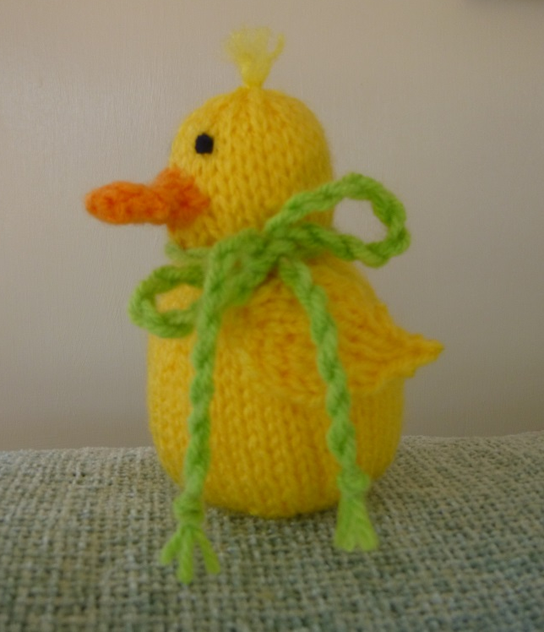
Abbreviations
K ~ knit
P ~ purl
Kfb ~ knit front and back into the stitch, therefore creating an extra stitch.
K2tog ~ knit 2 sts together
P2tog ~ purl 2 sts together
Skpo ~ slip 1, knit 1, pass slipped stitch over
St st ~ stocking stitch

Body and head
Cast on 6sts.
1. Kfb to end (12)
2. Purl
3. K1, kfb to end (23)
4. P
5. K1,( kfb, k1)to end (34)
6. P
7. K1 (kfb, k2) to end (45)
8. -16. Starting with a p row, work 9 rows of st st
17. K3 (k2tog, k4) to end (38)
18. P
19. (K2tog, k3) to last 3 sts, K2tog k1 (30)
20. P
21. K1, (k2tog, k2) to last st, k1 (23)
22. P
23. K1, (k2 tog) to last 2 sts, k2 (13)
24. P
25. Kfb (26)
26 -32. Starting with a p row work 7 rows in st st
33. K2tog to end (13)
34. P2 tog to last st, p1 (7)
Cut yarn and thread through remaining sts. Pull up to gather and fasten off.

Turn inside out and sew the seam at the back of the head, sew most of the body seam leaving enough room to turn right side out. Stuff fairly firmly and finish the seam. If required use the yarn ends and a sewing up needle to bring the yarn out through the top of the head. These ends can be trimmed and left as they are, or use a needle to tease them into a fluffy tuft.

Wings (use the same colour as the body and head or an alternative shade)
Cast on 3 sts
1. Kfb, k1, kfb (5)
2. Purl
3. K1, kfb, k1, kfb, k1 (7)
4. P
5. K2, kfb, k1,kfb,k2 (9)
6. P
7. K2, skpo, k1, k2tog, k2 (7)
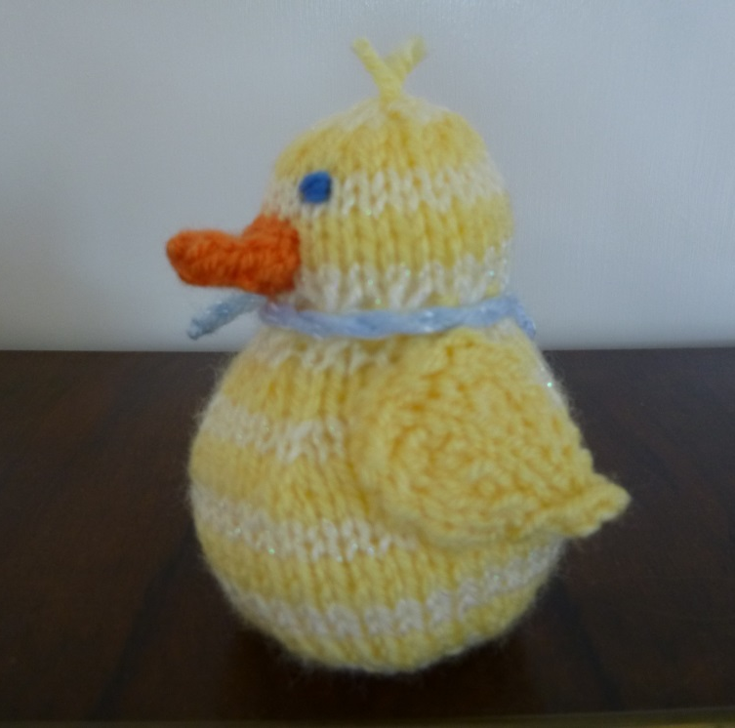
8. P
9. K1, skpo, k1, k2tog, k1 (5)
10. P
11. Skpo, k1, k2tog (3)
12. P
13. Skpo, k1, (2)
14. P2tog, fasten off.
For the second wing work in the same way until row 13.
13. K1, k2tog
14. As the first wing.

To make bigger wings add in an extra increase row:
7. K3, kfb, k1, kfb, k3 (11)
8. P
9. K3, skpo, k1, k2tog, k3 (9)
10. P
Carry on from the original row 7.

The wings should be leaf shaped, sew the wings into place on the side of the body, keeping the cast on sts towards the top and front while keeping the body seam in the middle at the back. You can sew round the whole wing or leave a section unsewn so it can curl up a little.

Eyes
Embroider two eyes using thin blue or black yarn, start and finish where the beak will be.

Beak
Using orange cast on 5 sts
1. K
2. P
3. K
4. P1, p2tog, p2 (4)
5. K1, k2tog, k1 (3)
6. P
7. K1, kfb, k1 (4)
8. P
9. K 1 kfb, k2 (5)
10.P
Cast off.
Fold beak in half and with right sides on the outside sew the side seams.
Sew the beak into place carefully, hiding the yarn used to make the eyes.

Scarf/Tag Tie

Take a long piece of yarn in any colour you fancy to complement your duck. It needs to be at least 4 times longer than the finished scarf. I use a piece approximately 10’ long. Fold in half and tie a knot at the free ends end. Pop this under your toe, under a chair leg or get someone to hold it while you start twisting from the other end. After a lot of twisting gently hold the middle (and both ends!) and let the yarn twist back on itself, it sounds tricky but it’s really easy! If the twist is too loose just gently pull it out again and twist some more. Tie a knot in each end and cut the ends to make it all neat.
Add the tag, tie a bow and hey presto! A cute duck!

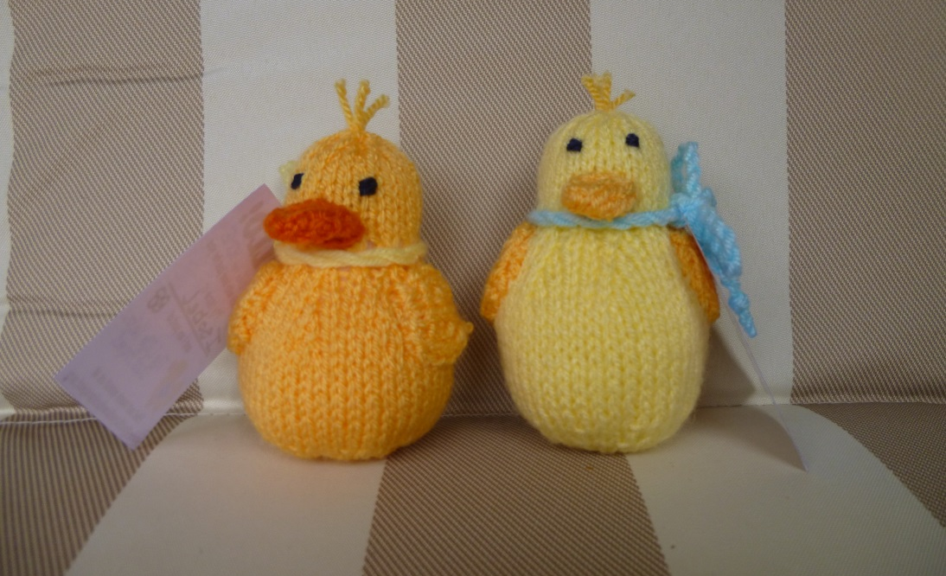

Although I am happy to let supporters of The Little Yellow Duck Project use this pattern, please do not sell any part of this pattern or reproduce it for any other reason.

